The forth 6images on Segmentation

*Enhancement the image

I=dicomread('knee_30.dcm');

J = histeq(I);

J1 = histeq(J);

J2 = histeq(J1);

J3 = histeq(J2);

J4 = histeq(J3);

J5 = histeq(J4);

J6 = histeq(J5);

J71 =double(J6);

J7 = imadjust(J6);

J8 = imadjust(J7);

J9 = imadjust(J8);

J10 = imadjust(J9);

J11 = histeq (J10);

J12=adapthisteq(J11);

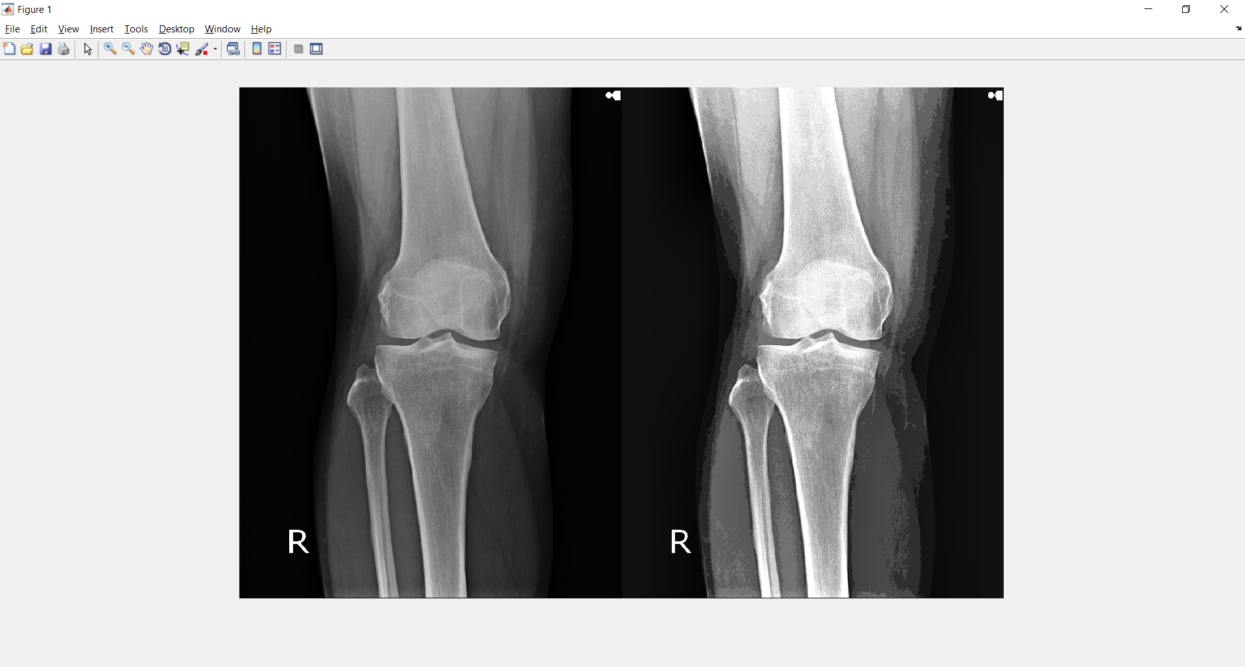

* Sobel on the crop image

q=imread('cropKnee30.jpg');

gray=rgb2gray(q);

[~, threshold] = edge(gray, 'sobel');

fudgeFactor = .99;

BWs = edge(gray,'sobel', threshold * fudgeFactor);

Imshow(BWs);

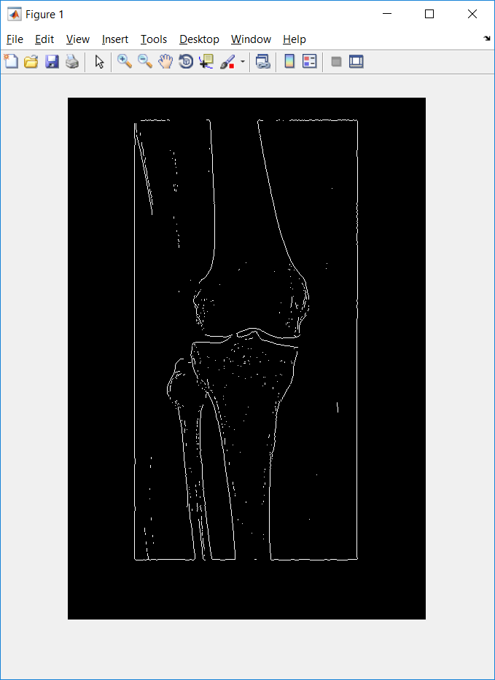

*Dilate the image

se180 = strel('line', 3, 180);

se0 = strel('line', 3, 0);

BWsdil = imdilate(BWs, [se180 se0]);

figure, imshow(BWsdil), title('dilated gradient mask');

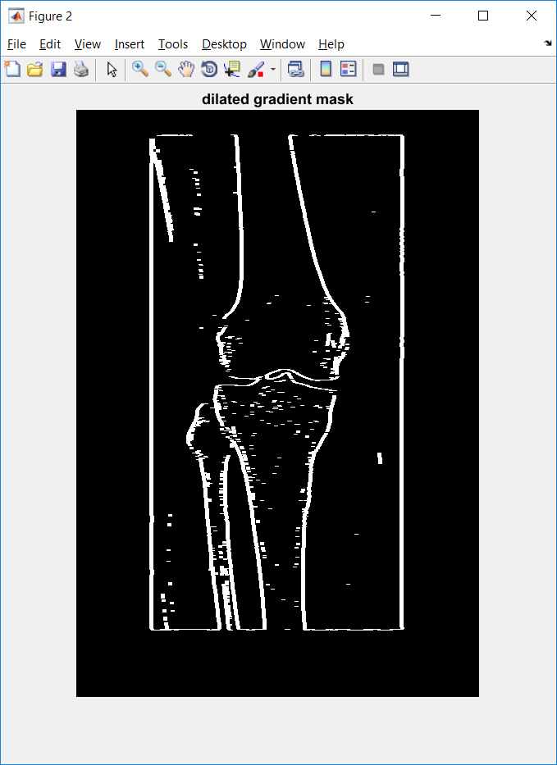

*Hole Filling

BWdfill = imfill(BWsdil, 'holes');

figure, imshow(BWdfill);

title('binary image with filled holes');

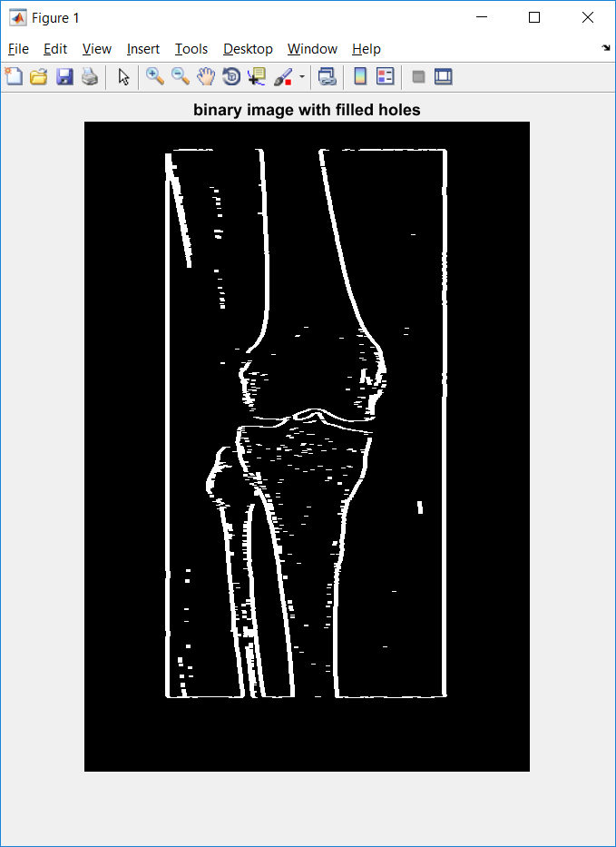

*borderless the

BWnobord = imclearborder(BWdfill, 1);

figure, imshow(BWnobord), title('cleared border image');

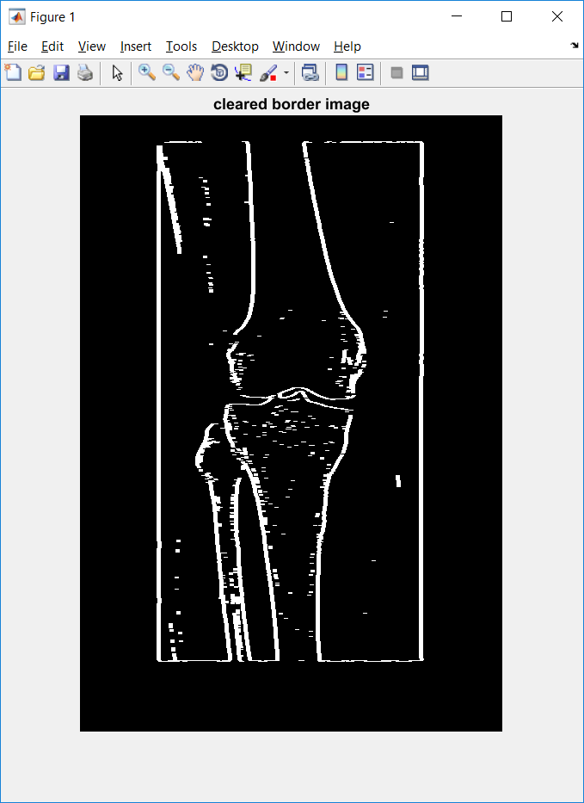

*Noise remove

K = wiener2(BWnobord ,[2 4]);

imshow(K);

